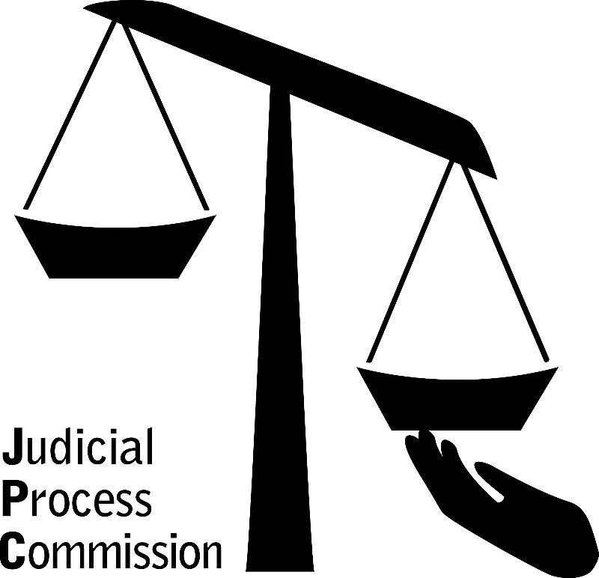

2021 Annual Report
October 2022

200 West Avenue, 2nd Floor, Rochester, NY, 14611
w. 585-325-7727 f. 585-325-2165
skp@rocjpc.org www.rocjpc.org

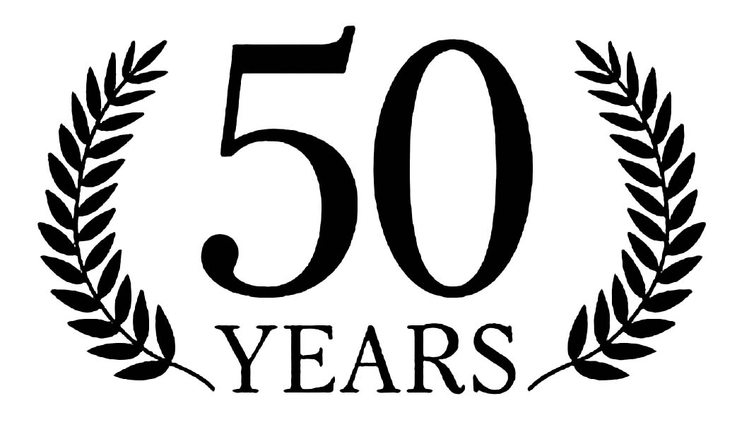

Presidents Message

Dear Friends:
It is a pleasure to serve as the Board President for this pillar organization within the Rochester community. For the past 50 years, the Judicial Process Commission (JPC) has been determined to support individuals in the City of Rochester impacted by the criminal justice system. Our agency's history is steeped in advocacy and commitment to our clients and community. When we recap this year for the agency, we are immensely proud of our accomplishments which include:
- Creation of a four-year strategic plan;
- Update of the agency’s Mission and Vision;
- Expanded client support services; and
- Office moved to the west side of the City of Rochester.

I am so excited about our future as we continue to affect the lives of families negatively impacted by the criminal justice system here in Rochester. Our hard work continues and we are committed to making a difference in the lives of those reentering the community.

The mission of JPC is as critical and relevant today as it was 50 years ago. On behalf of the board, I am confident that JPC will continue to carry out its mission with the creativity and dedication that has defined its history. I say thank you to the resolute board members who have supported JPC, the talented staff who worked with clients over the years, and especially, the adults and youth who have benefited from our support services.

Warmest Regards,
LaShana D. Boose
A Success Story

Meet Opal, a mother and New Journey client whose felony and resulting incarceration stemmed from one ongoing harassment issue, derailing her plans and leaving her unable to follow her dream to work in the medical field. In her words:

This has been a journey for me… I was arrested and …sentenced … to 4 months in jail and 5 years on probation. I haven't been in trouble since. I've kept a job ever since I've gotten released and my own housing and transportation. I have not been violated while on probation either, this is not the type of person I am ... I've always wanted a successful life and within a split decision my goals went down the drain. It's been extremely hard for me to move on with my life, and this is not what I wanted for myself. I need this certificate of relief to help me gain my power back in society to put me in positions that I want to be in to have better for myself and my family, the Judicial Process program has helped me out tremendously … through many obstacles through this program with transportation, housing, child care …I've also completed the Judicial Process Commission's New Journey program and gained my certificate, I am also working on getting my high school equivalency diploma…I just want better for myself and want to make my life easier by obtaining this certificate of relief.

Executive Director’s Message
Dear Friends,
2021 was a balancing act, adapting and adjusting to the wily pandemic. Flexible and dedicated staff safely delivered services to women and men and their families involved in the criminal justice system and kept everyone safe.
During 2021 the impact of the Covid-19 pandemic on criminal justice involved black and brown communities in Rochester caused disproportionate levels of illness, death, anxiety and loss, especially for those incarcerated.
Government and nonprofit agencies however provided the “silver lining” strengthening their partnerships with JPC and providing some significant new resources and relief.
In partnership with the City of Rochester, JPC moved to a more centrally located building in the historic Danforth Community Center in August 2021 with Exercise Express and WISH, U of R. Government partnerships allowed JPC to add several expanded services: emergency food, back rent/first month’s rent payments for struggling families and motel stays for homeless participants.
Our long-time partnership with the Monroe County Sheriff’s Office continued however the pandemic limited the delivery of two important programs: Men’s Support Group, Faith Community Adult Mentoring and the New Journey women’s therapeutic support group.
Our legal reentry project grew as we added new partnerships. LawNY, a long-time partner since 2006, the Monroe County Public Defender’s Office and the Center for Community Alternatives coalesced under the banner of Rochester Re-entry Advocates. This team provides: public education, legal advice, advocacy, restoration of jobs for those suspended or terminated by employers, and in some instances litigates against organizations denying employment/schooling to re-entry participants. Some participants are able to get their records sealed.
Rochester Housing Authority continued to provide a total of 17 housing vouchers for women and men with JPC staff providing support services. A collaborative focused on seamlessly serving women in reentry includes: U of R WISH, Exercise Express, Center for Economic Opportunity, CEO, & JPC. Through the use of peer navigators this effort seeks to empower criminal justice involved women to self-sufficiency.
I am grateful for six years of fundraising help from Margaret Corbin for hosting our NYS Legislative breakfast/lunch program at her home.
We give thanks to our dedicated and experienced New Journey therapeutic staff member Jeanette Gartland Creighton, LMSW, CASAC. Thank you for over 12 years of service. You have helped over 600 formerly incarcerated mothers and their children and donated extra hours benefiting so many families. I am grateful and give thanks to MacClurg Vivian for her long-time service to JPC and we wish her good luck on all her future endeavors.
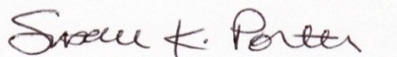
Sincerely,
Susan K. Porter, Executive Director
A Success Story

Meet Maris, a 26-year-old New Journey participant and mother. Maris has coped with a host of challenges in her life, including physical and mental abuse. She has taken responsibility for the actions and decisions that led to two serious charges, incarceration and probation. In her words:

“I have one 8-year-old daughter and I work full time as Personal Aide and Temporary Nursing Assistant. Accountability is one of the first and most important steps in trying to change myself. I take full responsibility for my actions I've made in the past…

While still incarcerated, I earned my High School Equivalency Diploma and joined a women's group called New Journey program with Judicial Process Commission (JPC) for mothers like myself ...

Following my release, I continued to work with JPC as we set goals for me to find myself a stable home and obtain employment. I worked at Dollar Tree for a year before I started work as a Personal Aide in March of 2021, where I am still employed. Shortly after starting my job as a Personal Aide, I moved into my own apartment where I still reside. Aside from working, I continued attending weekly therapeutic group sessions with the New Journey program…

In October of 2021, I received my Temporary Nursing Aide Certificate and have been working as a traveling CNA in addition to working as a Personal Aide… I've seen how hard this road has made my life and the strength it took to get to this point to apply myself and disclose my truth. Prosperity and success are what I yearn for and if you give me this opportunity it will NOT be taken for granted.”

JPC Vision & Mission

Vision. JPC envisions a transformed society, where formerly incarcerated community members are no longer marginalized and stigmatized and feel empowered to lead fulfilling lives.

Mission. JPC creates a just, non-violent community, striving to strengthen individuals seeking re-entry into society. We believe in and support the rights of all people affected by the criminal justice system and promote systemic changes that empower, inspire, and we provide person-centered, evidence-based, collaborative services. We advocate for positive change through mentorship, education, financial assistance, and other forms of advocacy.

JPC PROGRAMS AND SERVICES

Population Served.
Women, men, non-binary individuals and LGBTQA+ participants, 16 years and older, involved in the criminal justice system living in the greater Rochester community. The majority of JPC clients are people of color, most living in poverty/extreme poverty. Some are homeless, struggling with mental health issues or substance abuse, often unemployed/underemployed. 75% of our clients have children: many parents live apart from their children and are seeking to reunite with them.

Services/Programs. (During Covid-19 contacts with participants were mostly virtual)
JPC’s re-entry services include: linkages with temporary and permanent housing, therapeutic support groups & counseling, case management, service coordination, mentoring, wrap-around services, legal services, employment preparation including rap sheet reviews, Certificate of Relief from Disabilities or of Good Conduct and sealing.
Since 2010, JPC has developed a specialty serving high to moderate risk mothers and children, which we hope to extend to fathers as well. New Journey and Faith Community Adult Mentoring programs serve women and men, pre and post release, incarcerated in the Monroe County Jail, Albion or Orleans Correctional Facility or federal prison.

Legal Action Employability Project, Enhanced and Expanded (LAEPEE)
This first of its kind collaborative effort in NYS began in 2006 with Legal Assistance of Western New York - Rochester Office, and is designed to eliminate barriers that make it difficult for criminal justice involved women and men to rejoin the community and succeed in almost every important aspect of life, especially employment. We recently expanded our partnerships to include the Public Defender’s Office and Center for Community Alternatives for services and we call this collaboration Rochester Re-entry Advocates.

LAEPEE services include:
RAP Sheets (Records of Arrest and Prosecution) – JPC directly requests New York State/Federal Rap Sheets from the NYS Division of Criminal Justice Services and the FBI or through a company called IdentoGo. JPC staff review and summarize the RAP sheet and creates a conviction summary. In collaboration with legal partners, JPC determines the participant’s eligibility for a certificate of rehabilitation or sealing.

Certificates of Rehabilitation: This term encompasses both the Certificate of Relief from Disabilities and the Certificate of Good Conduct and both are an essential resource for returning citizens who are seeking employment. They are offered in just a few states to assist in the reduction of recidivism. Certificates lift bars to employment and licensure that result from a conviction history and may be used to demonstrate rehabilitation or a commitment to rehabilitation.
In NYS they are approved by a judge or the parole board and serve as legal evidence of rehabilitation. They may be required by an employer or by NY law for employment and licensure in over 100 professions.

Job Discrimination Education and Litigation: This service ensures that the employment rights of criminal justice involved persons are understood and enforced in New York. JPC staff obtain and correct the RAP sheets, call or write letters to employers and refer cases to LawNY Rochester Office for further advocacy and/or litigation.

LawNY Rochester Office activities include: assistance in obtaining back wages for participants that were illegally terminated/denied employment based on their criminal records; advocacy that permits suspended participants to continue to work or accept full time employment and preparations of applications for sealing a person’s criminal history.

Monroe County Public Defender’s Office, our newest partner is preparing and submitting applications for sealing of criminal history.

Center for Community Alternatives: spearheads Rochester Re-entry Advocates collaborative partnership coordinating our work including public speaking engagements and cooperatively writing a how-to manual for attorneys and advocates to use when obtaining, reviewing, and correcting records, preparing certificates and sealings, and advocating for clients.

Faith Community Adult Mentoring Project (FCAMP).
Trained volunteer mentors assist individuals returning from incarceration at the Monroe County Jail, Albion or Orleans NYS Correctional Facility or federal prison. Female and male volunteer mentors are matched with a mentee pre and/or post release. Mentors serve as a guide and coach to support the participant's successful return to our community.

New Journey.
New Journey continues the effort of the 2010-12 federally-funded Women’s Re-entry Project. The program works in collaboration with Monroe County Probation and the Jail, SAFE Court, Albion NYS Correctional Facilities or federal prisons to serve 50 high to moderate risk women with children post release each year.
Women receive intensive supports and case management services that may include: housing, family reunification, weekly therapeutic support groups, 1-on-1 counseling with a masters level licensed social worker, service coordination, mentors, legal services including preparation for employment, safe and affordable housing, wrap around services including: identification, used household items/baby items/furniture, first month’s rent/back rent, referral and advocacy for additional services such as: primary care, mental health, substance abuse treatment and welfare benefits.

JPC Housing for the Homeless.
Since 2010 the Rochester Housing Authority and JPC have partnered to provide permanent supportive housing to women and men with past criminal justice system involvement. JPC staff provide a variety of support services including face to face meetings and wrap-round services. Seventeen vouchers are provided for safe, affordable and permanent housing for homeless women and men. Participants for this program must be homeless, at least 18 years of age and have a long-term disabling condition.

 | 2021 | 634/2672 | 109/532 | 333/1306 | 175/813 | 17/21 | 342/1773 | 259/849 | 377/1755 | 2/15 | 3/7 | 11/53 | 12/98 | 3/23 | 32/50 | *COVID-19 | 278/228 | 222/177 | 56/51 | 194 | 52 | 58/35 | 51/35 | 7/0 | 7/18 | 46 | 15 | 39
 | 2020 | 594/1994 | 130/458 | 273/923 | 129/530 | 62/83 | 331/1183 | 240/775 | 130/739 | 1/3 | 2/8 | 4/8 | 6/26 | 1/2 | 22/33 | *COVID-19 | 154/97 | 134/85 | 20/12 | 185 | 30 | 38/19 | 35/18 | 3/1 | 8/19 | 26 | 18 | 53
JPC 2021 Service Statistics | 2019 | 645/1784 | 111/286 | 306/855 | 149/466 | 79/177 | 380/1134 | 237/598 |  | 1/7 |  |  |  |  | 27/45 | 695 | 239/235 | 200/198 | 39/37 | 92 | 19 | 160/113 | 148/109 | 12/4 | 10/31 | 25 | 20 | 49
JPC 2021 Service Statistics | 2018 | 558/1621 | 80/234 | 237/749 | 134/488 | 107/152 | 243/1003 | 141/353 |  | 1/2 |  |  |  |  | 173/263 | 607 | 223/167 | 190/147 | 33/20 | 127 | 17 | 100/66 | 90/62 | 10/4 | 16/41 | 27 | 17 | 57
JPC 2021 Service Statistics | 2017 | 727/2387 | 160/454 | 344/1221 | 169/577 | 54/135 | 358/1673 | 171/411 |  | 1/1 |  |  |  |  | 197/302 | 802 | 220 | 134/93 | 23/19 | 52 | 11 | 120/48 | 111/46 | 9/2 | 28/52 | 48 | 44 | 48
JPC 2021 Service Statistics | 2016 | 702/2271 | 106/345 | 325/1012 | 213/780 | 58/134 | 306/1081 | 316/1059 |  | N/A |  |  |  |  | 80/131 | 949 | 515 | 253/193 | 52/57 | 122 | 25 | 164/57 | 154/56 | 10/1 | 45/49 | 92 | 107 | 54
JPC 2021 Service Statistics | 2015 | 895/3043 | 141/442 | 418/1273 | 275/1151 | 61/177 | 306 | 465 |  | 3 |  |  |  |  | 121 | 1038 | 342 | 283/281 | 59/70 | 169 | 22 | 157/69 | 148/63 | 9/6 | 35/49 | 67 | 86 | 42
 |  | Unique Individuals Served/#Contacts | # Participants by age: 15-29/# of contacts | # Participants by age: 30-49/# of contacts | # Participants by age: 50+/# of contacts | # Participants by age: Unknown /# of contacts | # Participants by gender/# of contacts: Female | # Participants by gender/# of contacts: Male | # Sexual Orientation: Straight/# of contacts | # Sexual Orientation: Transgender/# of contacts | # Sexual Orientation: Gay/# of contacts | # Sexual Orientation: Lesbian/# of contacts | # Sexual Orientation: Bisexual/# of contacts | # Sexual Orientation: Other/# of contacts | # Clients gender unknown/# of contacts | # Unique Clients registered at reception | # State/Federal Rap Sheets Applied for/Received (Some clients have multiple RAP sheets) | # State RAPS Applied for/Received | # Federal RAPS Applied for/Received | # State RAPS Reviewed | # Federal RAPS Reviewed | # Certificates Applied for/Approved | # Certificate of Relief /Approved | # Certificate of Good Conduct /Approved | # Mentors trained/mentors active | # Participants receiving mentors | # Identifications obtained | # In Permanent Supportive/Community Housing

* COVID-19 & few office visits

A lot of people make JPC’s work happen!

8 Essential Community Partners - 2021

City of Rochester
MC Collaborative
Monroe County Office of the Sheriff
Rochester Re-entry Advocates: Center for Community Alternatives, Legal Assistance of Western New York - Rochester Office, Monroe County Public Defender’s Office
Rochester Housing Authority, Permanent Supportive Housing
RAWNY (Reentry Association of Western New York)
Women in Reentry Collaborative: UR WISH, Exercise Express, Center for Economic Opportunity, CEO

28 Community Collaborators – 2021

Action for a Better Community
Access VR
Bethany House
Catholic Family Center: Restart, Freedom House,
Liberty Manor, Sanctuary House
Delphi Rise
Foodlink
Health Homes, Unity Health System
Hope House-Salvation Army
Hope Initiatives
Huther Doyle
Jennifer House, Spiritus Christi Church
Monroe County Probation & Community
Corrections Department
Monroe County Office of the Public Defenders
Monroe County Reentry Task Force
NYS Commission for the Blind
NYS Division of Parole
Out of Darkness
Pathstone: Employment Programs & Wilson Commencement Park
Rochester Educational Opportunity Center (REOC)
RochesterWorks!
Saint Joe’s House of Hospitality
Salvation Army – Hope House
Strong Ties, University of Rochester
Urban League
Volunteers of American
Women’s Community Residence, Rochester Regional Health
YWCA housing programs

Organization Funders/In-kind Support—2021

Religious Organizations (12)
Artisan Church
Downtown United Presbyterian Church
Episcopal Diocese
First Presbyterian Church
First Unitarian Church
Lake Avenue Memorial
Mountain Rise UCC
Presbytery of Genesee Valley
Rochester Friends-Quakers
St Charles Borromeo
St. Peter’s Church
Third Presbyterian Church

Foundations (13)
Avangrid
Canandaigua National Bank
Daisy Marquis Jones Foundation
ESL Charitable Trust
Excellus Blue Cross Blue Shield
Mary S. Mulligan Charitable Trust
National Human Resources Association
Rochester Area Community Foundation:
LGBTQ+ Giving Circle
Rochester Women’s Giving Circle
Rochester Female Charitable Foundation
Fred & Floy Willmott Foundation
Marie C. & Joseph C. Wilson Foundation
Women’s Foundation of Genesee Valley
Other Organizations (3)
Driver Awareness Training
Monroe Community College
Roberts Wesleyan College
Government (2)
Monroe County EFSP/FEMA/CARES Funds

Current Board & Advisory Board Members – August 2022

LaShana D. Boose
City of Rochester
Board President
Helen Jae Cheves, Adjunct Faculty, SUNY Brockport
II Steps Ahead, President Chair Communications
Committee
Sara R. Hughes
Consultant
Communications Committee

Shermond Johnson-Reid
Good News Jail Ministry, Human Service Worker
Board Vice President

Karen A. Jones
Avangrid Service Company
IT Contracts Manager
Board Secretary

Joshua Wilcox
Foodlink
Strategic Initiatives Manager
Communications Committee
Cherie Wright- Banda
Monroe County Governance Committee
Advisory Board
John M. Klofas, Ph.D.
Director Emeritus, Center for Public Safety, RIT

Current Staff and Volunteers, August 2022
JPC staff and volunteers come to us through a variety of avenues.

STAFF

Susan K. Porter Executive Dir.

Annette Montstream LEAPEE, Program Director

Myril Stoudemire

Service Coordinator

Dorothy Chung Mentor Coordinator
Jeanette Gartland Creighton, LMSW CASAC Therapist/Case Manager

CONSULTANTS

Colin Fleming -Stumpf

Grant Writer

Laurie Colasurdo

Bookkeeper

VOLUNTEER STAFF
Robert Conklin and Alex Hrabko Information Tech.

Admin. Support
Edward Johnson Notary and Judy Johnson

Website
Matthew Weeg

IN-KIND LEGAL

STAFF

Scott Forsyth, Esq.

LawNY Rochester

Monroe County Public Defender’s Office
Center for Community Alternatives

Active Mentors – August 2022

Dorothy Chung
Shoneyc Davis
Marco DiGiovanni
Krystal Ellis
Barbara Grosh
Michelle Horman
Tim Hinton
Deborah Glee
David Kotak, MD
Geneva McLain
Stephen Metildi
Danny Mitchell
Robert Picco
Susan Porter
Timothy Rawlins
Brenda Rivera
Ervin Vereen
Randy Williams

Monday Night Workshop & Men’s Group Facilitator
Clyde Williams

Judical Process Commission
200 West Avenue, 2nd Floor, Rochester, NY, 14611
w. 585-325-7727 f. 585-325-2165
skp@rocjpc.org www.rocjpc.org

